

Newsletter

Autumn 1 2023

In this newsletter

. Ofsted

. Hello/Goodbye

. Preparation for Adulthood

. Creative Curriculum – New Directions

. Mornings at Pear Tree

. Parents’ Evening

. Dates for diaries

It has been a really exciting start to the new school year and it was wonderful to welcome back all of the children following the summer break. The site team had worked extremely hard this summer and school was sparkling on our return. It feels like we have experienced all four seasons within this first half term and the children have all had some great opportunities for outdoor learning.

This year’s focus for further improving the Quality of Education at Pear Tree will be to ensure that our provision and curriculum is further personalised to meet the ever-changing needs within our settings. Please see later in the newsletter for more information on this.

I very much enjoyed seeing so many of you at our recent Open Afternoons and it was so lovely that many of you were able to stay on for the ‘Tea and Talk’ after. We will be planning another one of these soon.

I look forward to working alongside all of you over the coming academic year and thank you in anticipation of your support.

With the warmest of wishes

Kate



**Ofsted**

It is now absolutely amazing to be able to shout from the rooftops that Pear Tree School remains OUTSTANDING!

We are all delighted with the outcome of our inspection and it truly reflects all the hard work that goes into our school on a daily basis from our staff, parents, governors, families, community but most importantly, from our children.

The children shone throughout the inspection and the inspector was blown away by the individual progress being made.

Thank you so much to everyone who responded to the parent survey as part of this. I must admit that I had a tear in my eye when the inspector read out some of your comments.

I look forward to celebrating our achievement with some of you at the celebration event at Ribby Hall this week.

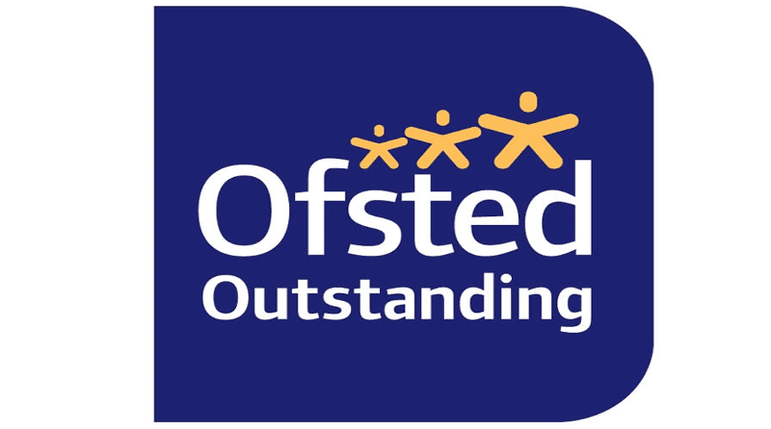

**Hello / Goodbye**

We have welcomed some new pupils to Pear Tree this academic year. In our Seedlings class we have Woody, Henry, Marie and Jack. In the Sixth Form we have Oliver and Matthew and in the Compass Centre we have Ciaran, Riley and Alfie. All the staff have been enjoying getting to know these new pupils and are excited to see how they develop.

At the end of this half term we will be saying goodbye to two teaching assistants – Emma (Pine Tree) and Sammy (Compass Centre). Both members of staff have provided incredible support to our pupils and we wish them all the best in their next venture.

**Preparation for Adulthood**

Across our school we promote pupil voice and the importance of pupils having a choice. This approach to communicating wants and needs with familiar people ranges from errorless choices such as whether the pupil wants a drink before or after playtime to what they would like for their lunch. As some of our pupils grow older, there may be bigger decisions to be made such as which respite group they would like to attend or even where they want to live!

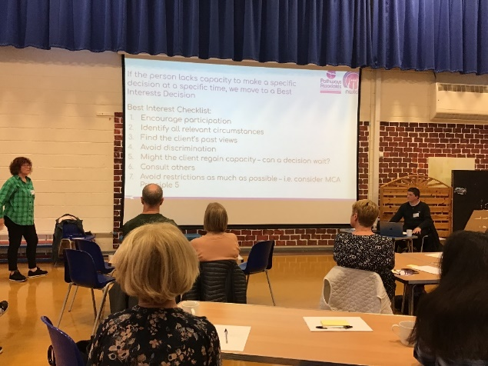

From age 16, the Metal Capacity Act comes into play for everybody. This is a law that helps people with making decisions for themselves and how they are supported if people need help to make decisions. There are 5 main principles of the Mental Capacity Act which can be seen in the poster below.



From our experience in supporting families within the 14-19 department, we know that thinking about our pupils growing older can be an anxious time for families. We therefore offered a training event to provide information and advice about the Mental Capacity Act and the roles that parents and other professionals may play in making decisions as pupil’s age. The session was really well attended by parents and carers. Feedback following the session showed that most parents knew a little about the Act before the training commenced with many parents reporting that they felt that they learnt something useful in preparing for the transition process and adulthood more generally.

We are always open to ideas in how we can further support pupils and families as they move through school and begin to think about transition so please feel free to get in touch if there is something specific that you think we could offer next time.

**Creative Curriculum - New Directions**

We started our new curriculum theme ‘new directions’ with an exciting exploration of activities linked to our Geography topics in the hall. We delved into the exciting world of volcanoes which saw us creating volcanic explosions using lemonade and bicarb, this was very exciting and the pupils loved the anticipation. There was an opportunity to explore another country where we took a trip to Paris, exploring the French tastes of garlic and pain au chocolate and becoming engineers with the opportunity to build our own Eiffel towers. Pupils could visit the scoot board airport and travel to the Kirkham station to create their own town artwork after listening to key vocabulary on switches, learning the linked Makaton signs.

Throughout the half term classes have used the creative curriculum theme to enhance the learning opportunities for pupils. The MSI group have physically gone in new directions as they embarked on their new adventure of working in new groups each morning, pupils have been learning through a sensory story about growth and travelling along with exploring their new morning class community.

Classes have enjoyed starting their new Geography topics including Cumbria where pupils have looked at leisure activities with cultural capital opportunities to role play what it is like to go camping. Another class has been exploring weather, enjoying lots of sensory experiences through Attention Autism.

Compass Centre joined in with inspiration day activities and enjoyed tasting the garlic bread so much that they have focussed our cooking sessions around French foods this term. Their Attention Autism sessions have follow the topic of new directions using the topic of seasons and celebrations while their literacy texts have both been about travelling to faraway places. Pupils have also had opportunity to travel by different means, with some pupils starting horse riding and others scaling up rock climbing walls!

Pupils have re-started exciting travel training opportunities out in the community, with new year 7s accessing some of their first travel training trips with Mark. Students have had the opportunities to visit Lytham St Annes, Lancaster and the local community.

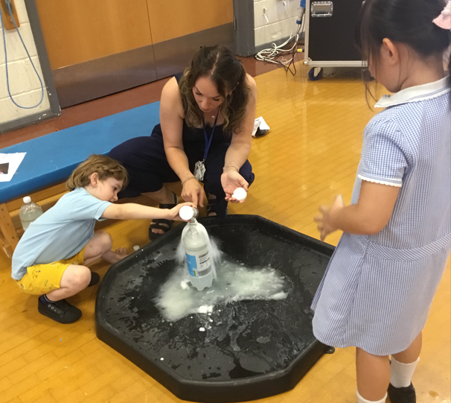

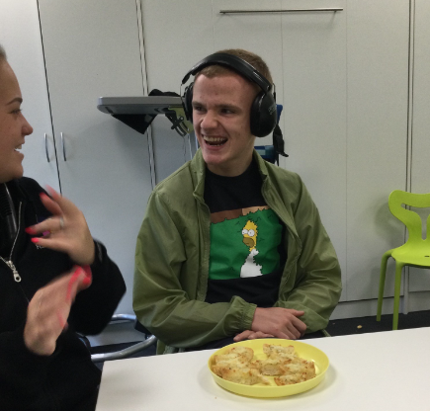

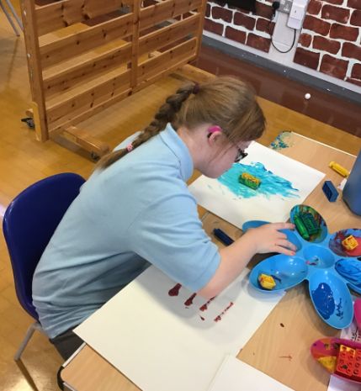

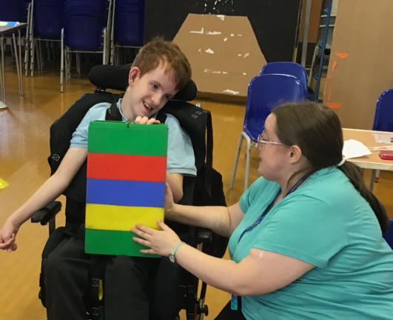

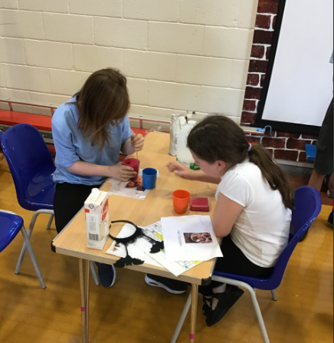

**Mornings at Pear Tree**

As you have already been informed, our morning sessions are now organised slightly differently this year. We have created two additional teaching groups specifically to focus on those pupils who need a more multi-sensory learning environment. These pupils need time, space and quiet to make progress with their communication and key learning skills and these groups allow for this opportunity. This then means that the pupils left in their original class can increase their learning potential due to lower numbers in the room and increasing the pace of lessons. All children come back to their ‘base’ class for lunch and afternoon sessions and so far, we have only seen a positive impact from this.



**Parents’ Evening**

Our Annual Parent’s Evening will take place on Wednesday 8th November from 4.30pm to 6.30pm. Information and bookings can be found on School Spider and I look forward to seeing you all there.



Dates for diaries

Wednesday 18th October 5pm-8pm Ofsted Celebration at Ribby Hall

Friday 20th October School closes for half term break

Wednesday 8th November 4.30pm-6.30pm Parents’ Evening

Friday 17th November 9.15am Elm Tree Class Assembly

Monday 18th and Tuesday 19th December Lower School Nativity (more details to follow)

Thursday 21st December Christmas Party Day

Friday 22nd December School closes for Christmas